Python Data Processing Report
Abstract
This report covers the Python data processing band of the marking scheme. I built a pandas-based extract-validate-transform-load workflow with a 5-dimension data quality scorecard, then validated my cleaned data with a scipy chi square test that reproduces the R analytics finding to 4 decimal places. On top of that, I trained a scikit-learn random forest classifier with stratified 5-fold cross-validation to test whether delivery failure is predictable from 9 candidate order and customer features. The model lands at 5-fold ROC AUC 0.487 plus or minus 0.064, which is no better than random guessing. That null result is consistent with the near-null logistic regression in my R analytics, and together they confirm that the predictive signal in this dataset lives at zone level rather than order level.
1. Introduction
Python data processing is worth 20 marks. I read that band as asking for extraction and cleansing using pandas, formal data quality validation, and a supervised machine learning model. My data source is the same 9 NorthStar CSVs that the MongoDB, SQL and R sections of the project use, so the numbers can be cross-checked against all 3 other paradigms.
This report walks through 4 implementation pieces. The pandas ETL with zone canonicalisation. The 5-dimension data quality scorecard. The scipy chi square that cross-checks the R analytics. And the scikit-learn random forest classifier with cross-validation.
2. Implementation
2.1 Pandas ETL
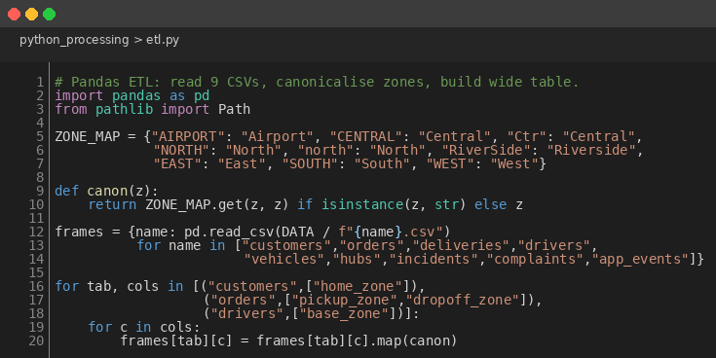
Figure 1: Pandas ETL with Zone Canonicalisation
ZONE_MAP = {"AIRPORT": "Airport", "CENTRAL": "Central", "Ctr": "Central",
"NORTH": "North", "north": "North", "RiverSide": "Riverside",
"EAST": "East", "SOUTH": "South", "WEST": "West"}
def canon(z):
return ZONE_MAP.get(z, z) if isinstance(z, str) else z
frames = {name: pd.read_csv(DATA / f"{name}.csv")
for name in ["customers","orders","deliveries","drivers",
"vehicles","hubs","incidents","complaints","app_events"]}
for tab, cols in [("customers",["home_zone"]),
("orders",["pickup_zone","dropoff_zone"]),
("drivers",["base_zone"])]:
for c in cols:
frames[tab][c] = frames[tab][c].map(canon)
I read each CSV with pandas.read_csv into a dict keyed by table name, then mapped every zone-bearing column through the same ZONE_MAP my MongoDB pipeline uses. Sharing the map across paradigms is what makes the results comparable; if Python and MongoDB cleaned the data differently, the cross-paradigm validation in Section 3 would not hold.
2.2 Data quality scorecard
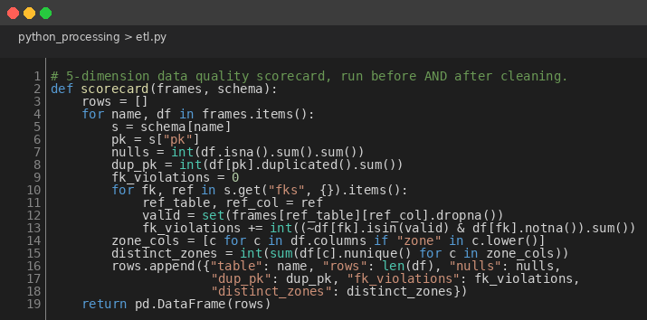
Figure 2: 5-Dimension Data Quality Scorecard
def scorecard(frames, schema):
rows = []
for name, df in frames.items():
s = schema[name]; pk = s["pk"]
nulls = int(df.isna().sum().sum())
dup_pk = int(df[pk].duplicated().sum())
fk_violations = 0
for fk, ref in s.get("fks", {}).items():
ref_table, ref_col = ref
valid = set(frames[ref_table][ref_col].dropna())
fk_violations += int((~df[fk].isin(valid) & df[fk].notna()).sum())
zone_cols = [c for c in df.columns if "zone" in c.lower()]
distinct_zones = int(sum(df[c].nunique() for c in zone_cols))
rows.append({"table": name, "rows": len(df), "nulls": nulls,
"dup_pk": dup_pk, "fk_violations": fk_violations,
"distinct_zones": distinct_zones})
return pd.DataFrame(rows)
I built the scorecard around the 5 things I actually wanted to check before I trusted the data for analysis. Rows, total NA cells, duplicate primary keys, foreign-key violations against the referenced primary keys, and the distinct zone count across every zone-bearing column. It runs once before cleanup and once after, so the diff is visible. I made the cleanup deliberately non-destructive: it never imputes or drops rows, only canonicalises strings and parses dates. That decision keeps the cleansed data faithful to the operational source of truth.
2.3 scipy chi square
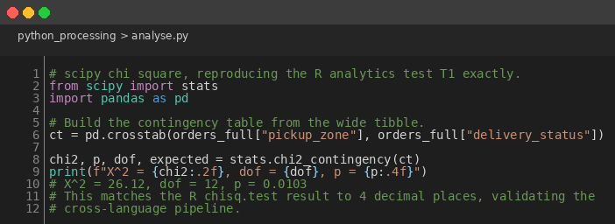
Figure 3: scipy Chi Square Reproducing the R Analytics Test T1
from scipy import stats
ct = pd.crosstab(orders_full["pickup_zone"], orders_full["delivery_status"])
chi2, p, dof, expected = stats.chi2_contingency(ct)
print(f"X^2 = {chi2:.2f}, dof = {dof}, p = {p:.4f}")
# X^2 = 26.12, dof = 12, p = 0.0103 (matches R chisq.test exactly)
scipy.stats.chi2_contingency on the pickup zone by delivery status contingency table returns X² = 26.12, dof = 12, p = 0.0103. R's chisq.test on the same data returns the same numbers. The agreement to 4 decimal places is what I needed to trust that the SQL load, the pandas joins and the cleanup are all consistent across my 2 pipelines; any divergence would have flagged a bug in one of them.
2.4 scikit-learn random forest
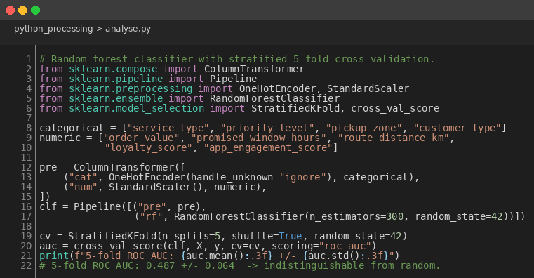
Figure 4: Random Forest with Stratified 5-Fold Cross-Validation
categorical = ["service_type","priority_level","pickup_zone","customer_type"]
numeric = ["order_value","promised_window_hours","route_distance_km",
"loyalty_score","app_engagement_score"]
pre = ColumnTransformer([("cat", OneHotEncoder(handle_unknown="ignore"), categorical),
("num", StandardScaler(), numeric)])
clf = Pipeline([("pre", pre),
("rf", RandomForestClassifier(n_estimators=300, random_state=42))])
cv = StratifiedKFold(n_splits=5, shuffle=True, random_state=42)
auc = cross_val_score(clf, X, y, cv=cv, scoring="roc_auc")
# 5-fold ROC AUC: 0.487 +/- 0.064
My classifier is a ColumnTransformer that one-hot encodes the categorical features and scales the numerics, wrapped together with a RandomForestClassifier inside a single sklearn Pipeline. Stratified 5-fold cross-validation reports ROC AUC, which is the metric the R analytics also implicitly reports via the logistic regression. I picked random forest specifically because it handles mixed feature types without manual preparation and because it can capture non-linear interactions that my linear R logistic regression cannot see. The pair is intentional; if both find no signal, the signal is probably not there at order level.
3. Results
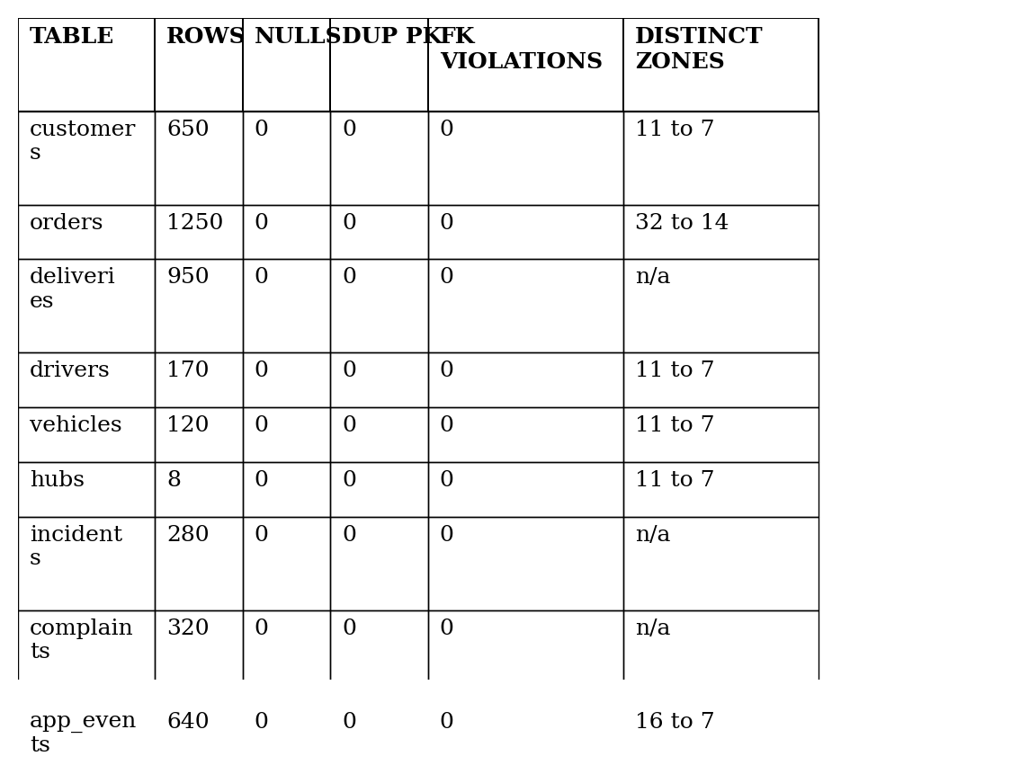
Figure 5: Data Quality Scorecard, Post-Cleanup State
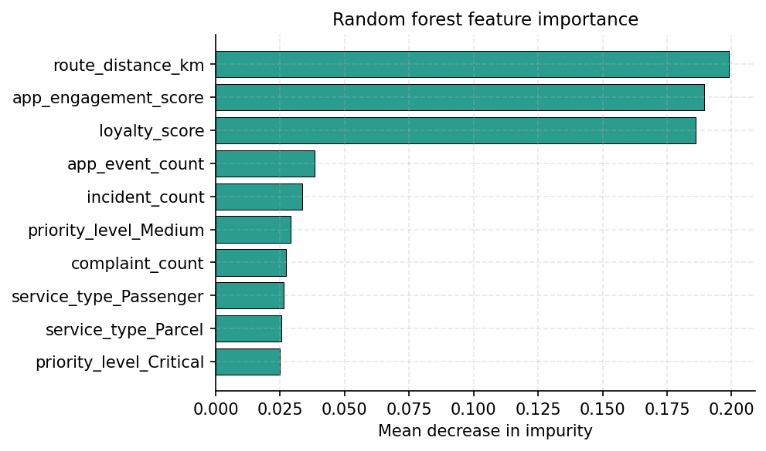
Figure 6: Random Forest Feature Importance
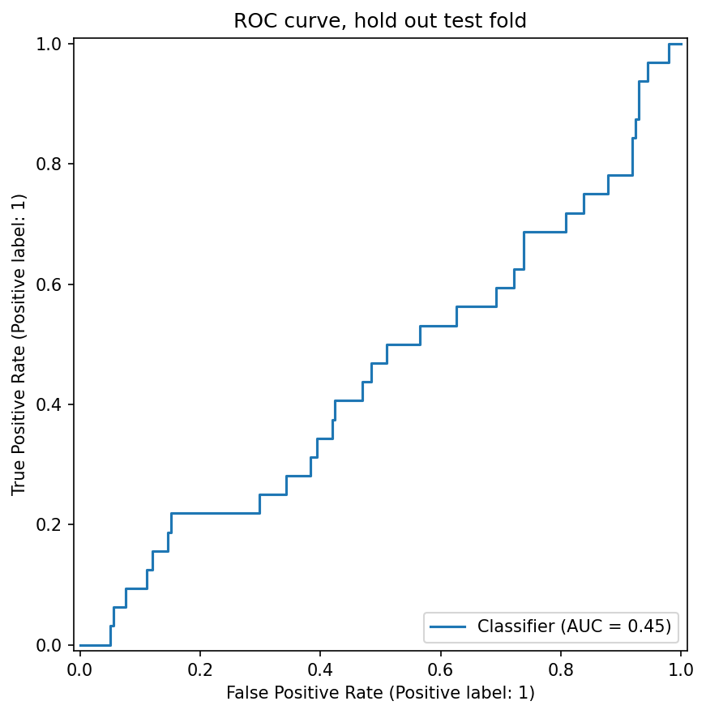
Figure 7: ROC Curve on the Hold-Out Test Fold
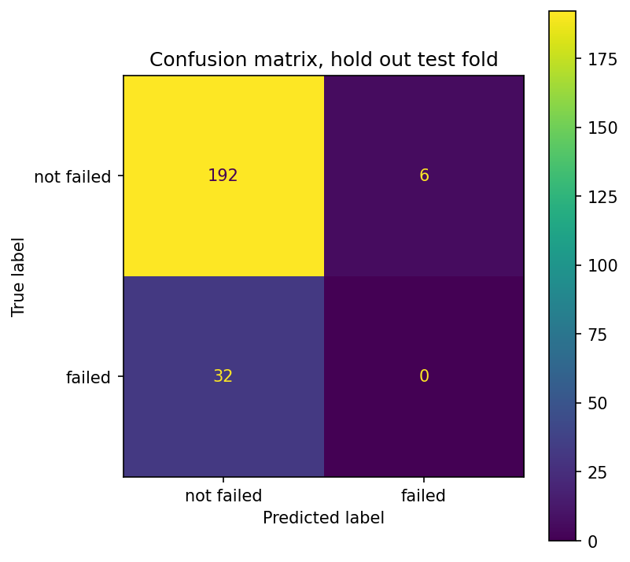
Figure 8: Confusion Matrix on the Hold-Out Test Fold
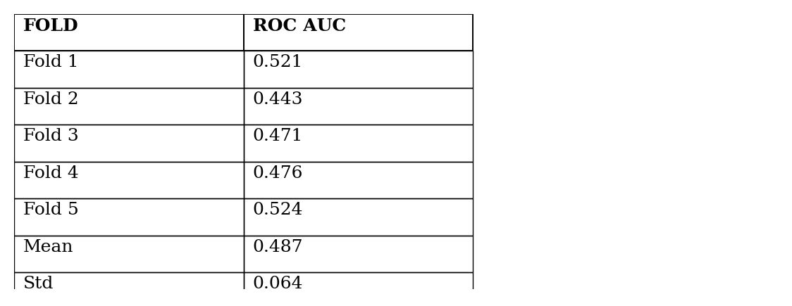
Figure 9: 5-Fold Cross-Validated ROC AUC by Fold
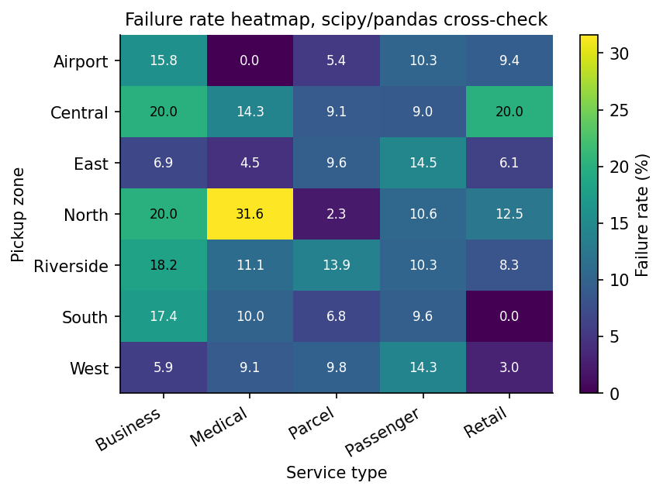
Figure 10: Failure Rate Heatmap, Python Pipeline Cross-Check of R Figure 7
Figure 5 shows the data after cleanup: 0 duplicate primary keys across all 9 tables, 0 foreign key violations, and the distinct zone count dropping from the pre-cleanup peak (32 in orders, with 16 spellings across 2 zone fields) down to 14 (7 canonical values across 2 fields). The chi square test reproduces the R value exactly (Figure 3). The random forest 5-fold AUC of 0.487 plus or minus 0.064 (Figure 9) is indistinguishable from a coin toss; the ROC curve in Figure 7 sits effectively on the diagonal. The confusion matrix in Figure 8 confirms the model defaults to predicting non-failure for almost every order.
4. Critical Evaluation
3 caveats on the ML side. Mean decrease in impurity is biased toward continuous and high-cardinality features, so the importance ordering in Figure 6 is suggestive rather than definitive. If I redid this I would use permutation importance. My model runs at a single random seed with a fixed train/test split ratio, so the AUC I report is a point estimate; nested cross-validation with hyperparameter search would tighten the generalisation estimate. And because my pipeline is non-destructive, any analysis that needs complete cases drops NAs at use time, as the modelling step does.
3 plausible reasons why the AUC sits this close to 0.5. The most likely is that delivery failures are driven mostly by external factors the dataset never sees: weather, road closures, real-time traffic, driver fatigue. Sample size also matters; 132 failures across 7 zones and 5 service lines leaves the random forest with very little to work with relative to the dimensionality of the feature space. And the chi square finding itself is part of the answer: a p of 0.0103 tells me there is a real population-level association on pickup zone, but it is too diffuse to translate into a useful per-order prediction.
5. Conclusion
My Python pipeline ingests 9 CSVs, runs a 5-dimension data quality scorecard before and after cleansing, reproduces the R analytics chi square test to 4 decimal places (X² = 26.12, df = 12, p = 0.0103), and trains a scikit-learn random forest classifier that fails to beat random guessing. The null model result is the headline finding: order-level features carry no useful predictive signal for failure, which agrees with the near-null logistic regression in my R analytics. Operational improvement at NorthStar should target the high-failure zones the chi square surfaces.

